## **Project 01**

### **Objectives:**

* Create and manage Docker volumes for data persistence.
* Set up a Docker network for container communication.
* Use Docker Compose to manage multi-container applications.
* View and manage Docker logs.
* Deploy the application using Docker Swarm.

### **Project Outline:**

1. **Create Docker Volumes**
2. **Create a Docker Network**
3. **Write a Docker Compose File**
4. **Deploy the Application with Docker Compose**
5. **Manage Docker Logs**
6. **Deploy the Application Using Docker Swarm**

### **Step-by-Step Guide**

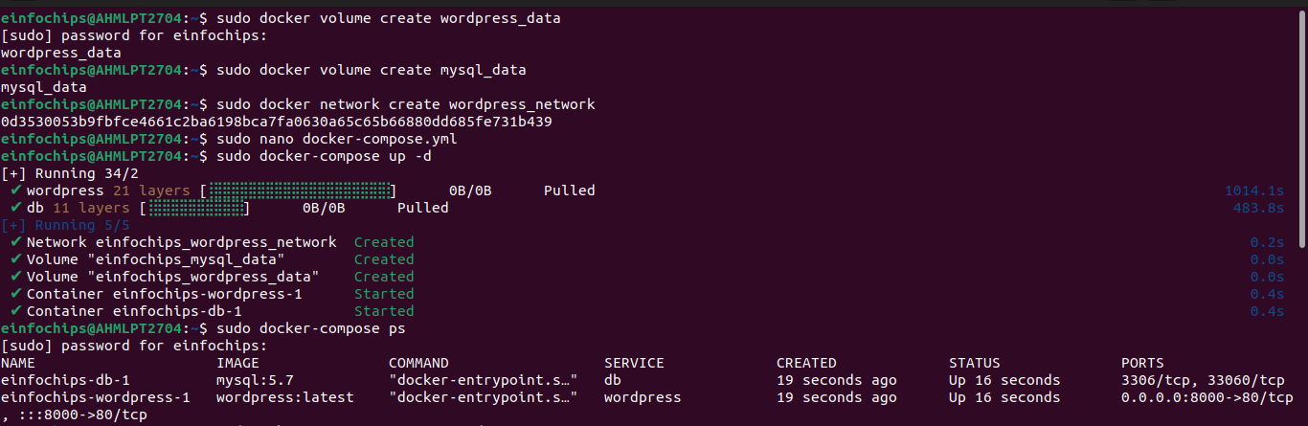

#### 

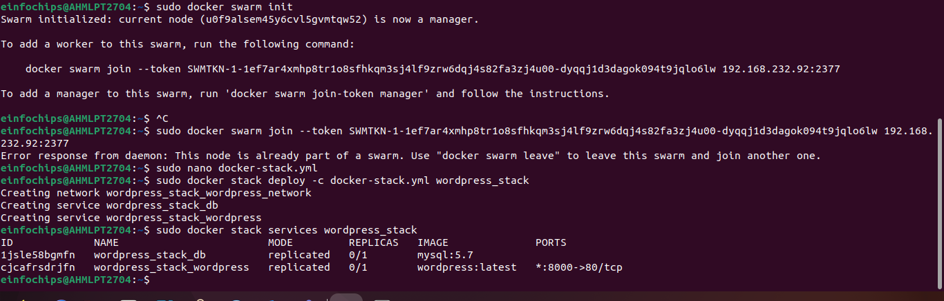

## **Project 02:**

## **Objectives:**

* Deploy an application across multiple Docker Swarm worker nodes.
* Place specific components on designated nodes.
* Monitor and troubleshoot using Docker logs.
* Modify and redeploy the application.

### **Project Outline:**

1. **Initialize Docker Swarm and Join Worker Nodes**
2. **Label Nodes for Specific Component Placement**
3. **Create a Docker Stack File**
4. **Deploy the Application**
5. **Monitor and Troubleshoot Using Docker Logs**
6. **Modify and Redeploy the Application**

### **Step-by-Step Guide**

#### 

#### **3. Create a Docker Stack File**

